Adaptive Noise Reduction for Engineering Drawings Based on Primitives and Noise Assessment

Jing Zhang Wan Zhang Liu Wenyin
Department of Computer Science, City University of Hong Kong, Hong Kong SAR, PR China
{jzhang,wanzhang, csliuwy}@cityu.edu.hk

Abstract
In this paper, a novel, adaptive noise reduction method for engineering drawings is proposed based on assessment of both primitives and noise. Unlike the current approaches, our method takes into account the special features of engineering drawings and assesses the characteristics of primitives and noise such that adaptive procedures and parameters are applied for noise reduction. For this purpose, we first analyze and categorize various types of noise in engineering drawings. Algorithms for linewidth assessment, noise distribution assessment and noise level assessment are then proposed. These three assessments are combined to describe the features of noise of each individual engineering drawing. Finally, median filters and morphological filters, which can adjust their template size and structural element adaptively according to different noise level and type, are used for adaptive noise reduction. Experimental results show that our approach is effective for reducing most noise in engineering drawings.

Keywords: Adaptive Noise Reduction, Engineering Drawings, Linewidth Assessment, Noise Assessment
1. Introduction
Noise reduction is a fundamental problem ([1], [2], and [3]) of image processing and pattern recognition, which attempts to recover an underlying perfect image from a degraded copy. It plays an important role in automatic engineering drawings analysis since engineering drawings are usually scanned from paper drawings or blueprints, in which many factors may generate noisy document images. The noises in engineering drawings can be in different types and levels, which greatly affect the results of vectorization, recognition, and other processing, and hence, dramatically reduce the overall performance of engineering drawings analysis.
Current approaches to noise reduction can be broadly classified into order statistical methods, transform domain methods, and fuzzy methods. In order statistical methods, median filter [4] and rank order filter [5] are representatives, which use statistical theory to detect and reduce noise in images. Transform domain methods apply signal processing methods to noise reduction by using transformation methods, such as Fourier Transform and Wavelet Transform [6]. Fuzzy methods seek to use nonlinear filters and learning theories, such as fuzzy filters [7] and neural networks [8], to reduce noise.
Although many approaches have been proposed to various noise reduction problems, engineering drawings were not paid much attention to. Current approaches ignore the special features of engineering drawings and different types and levels of noise. They employ general image processing methods to reduce noise in engineering drawings. Although they do achieve some promising results, noise reduction for engineering drawings is still not always satisfactory.
In this paper, we assess the noise of engineering drawings from two aspects: 1) linewidth of primitives, and 2) distribution and level of noise, based on which we can apply adaptive noise reduction. The arrangement of the paper is as follows: In Section 2, we analyze the special features of engineering drawings and categorize the noise into different types and levels. In Section 3, we present our linewidth assessment algorithm based on medial axis transform. In Section 4, we discuss our methods used to assess noise distribution and noise level. The adaptive noise reduction (ANR) method is proposed in Section 5. Some experimental results are shown in Section 6 and conclusions are shown in Section 7.
2. Features & Noise in Engineering Drawings
Engineering drawings have certain special features: 1) the possible linewidths are limited to several discrete values; 2) the edge of primitives (e.g., lines and arcs) is smooth; 3) the background and the primitives are monochrome. Figure 1 shows four engineering drawings with different qualities. From Figure 1(a) we see that the linewidth of primitives is nearly equal and the edge of primitives is smooth. There is no noisy point on either background or primitives. However, the qualities of the other three are not so good due to different types and levels of noise.
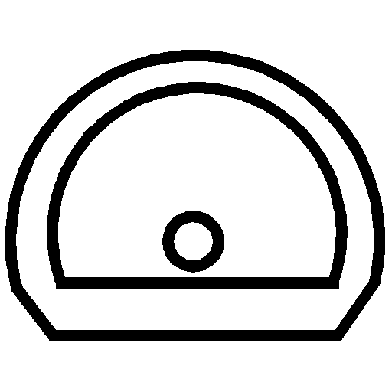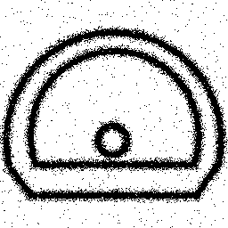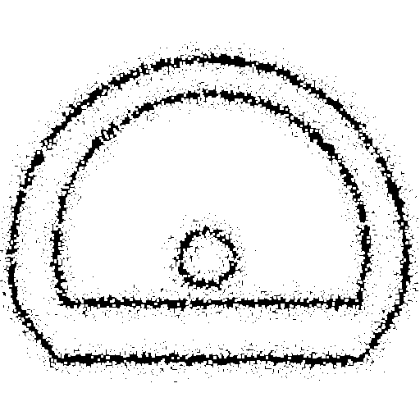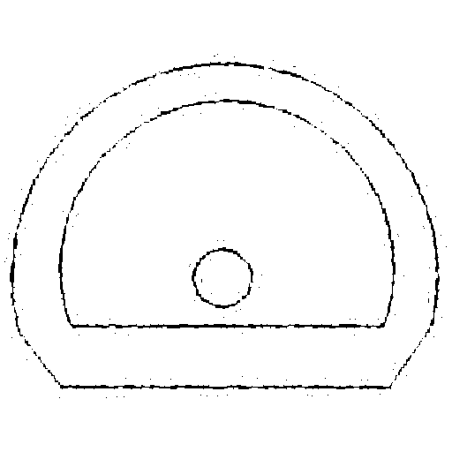
(a) (b) (c) (d)
Figure 1. An example of engineering drawings
There are various types and levels of noise in engineering drawings, as classified and modelled by existing researchers. Pavlidis [9] enumerated three types of distortion noise generated by scanners. Kannugo et al. [10] explored a nonlinear global and local document degradation model. Zhai et al. [11] summarized four types of common noise in engineering drawings (i.e., Gaussian noise, high frequency noise, hard pencil noise, and motion blur noise) and validated their models.
For binary engineering drawings, we categorize the noise into three basic types: 1) Gaussian noise, 2) high frequency noise, 3) hard pencil noise. In addition to types, the noise in engineering drawings can be at different levels, which indicate how noisy the images are. Next, we will discuss the assessment of image quality in terms of both primitives and noise.
3. Linewidth Assessment of Primitives
In this section, we discuss the detail of our proposed method for linewidth assessment. As we mentioned previously, the linewidths of primitives, such as lines and arcs, in engineering drawings are limited to several values. Although different types of noise are generated with different levels, the linewidth is nearly unchanged and the distance between primitives is usually much greater than their linewidths, otherwise human cannot distinguish the gap between primitives. In addition, the size of a noisy region is usually smaller than linewidth, otherwise even human cannot distinguish useful data from noisy data. Hence, linewidth is very important information for both preserving useful features and removing noise.
We use a thinning algorithm based on Medial Axis Transform (MAT) [12] to calculate the average linewidth. MAT uses a recursive method to extract the skeletons of primitives from a binary image. In each iteration, the points satisfying certain conditions are removed from the primitives. The skeleton obtained by MAT consists of the set of points that are equally distant from two closest points of the boundary of primitives. Assume that the total number of iteration required is I, the linewidth after the i^{th} iteration is $d_{i}$, and the number of points that have just been removed from the primitives during the i^{th} iteration is $N_{i}$. The lines are thinned at both sides when $d_{i}\text{>=}2$, that is, $d_{i+1}=d_{i}−2$. When $d_{i}=2$, the lines are only thinned by one pixel, that is, $d_{i+1}=d_{i}−1$，$i∈[1,I−1]$.
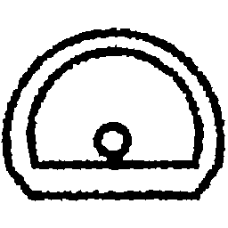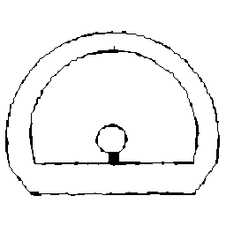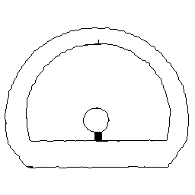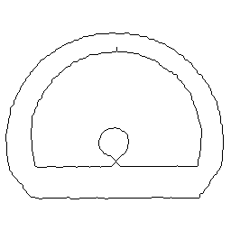
(a) (b) (c) (d)
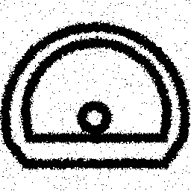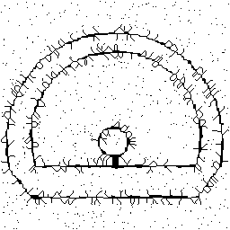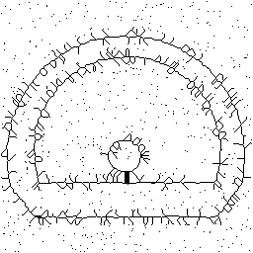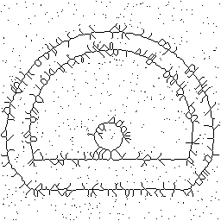
(e) (f) (g) (h)
Figure 2. Examples of thinning procedure
(a) is the original image; (b) and (c) are the thinned images of (a) after the 4th and 5th iteration, respectively; (d) is the skeleton image of (a). (e) is (a) with some noise added; (f) and (g) are the thinned image of (e) after the 4th and 5th iteration, respectively; (h) is the skeleton image of (e).

Obviously, $N_{i}$ becomes smaller when i increases. Finally, when $N_{i}=0$, it means the skeleton is extracted from the primitive successfully. As mentioned in Section 2, a characteristic of engineering drawings is that the linewidths are almost equal. It means that linewidths of most primitives become one pixel at the same time during the thinning procedure. Hence, in the first several iterations, the change of $N_{i}/N_{1}$ is small but at some iterations it dramatically drops. In Figure 2, (a) is an original image, (b), (c) and (d) illustrate the thinned images of (a) at different iteration. In Figure 3, (a) and (b) illustrate the curves of $N_{i}/N_{1}$ and $(N_{i}−N_{i+1})/{N_{1}}$ during the thinning process of Figure 2(a). We can see that $N_{i}/N_{1}$ has sharp drops at the 4th and 5th iterations. Correspondingly, nearly all lines become one pixel wide after the 5th iteration except the part where the circle and line touch together, as shown in Figure 2(b) and (c). All the 6th to 11th iterations are used to thin this conjoint part only, whose width cannot reflect the real linewidths of primitives. Hence, the changes of $N_{i}/N_{1}$between the 6th to 11th iterations become small and these iterations should not be taken into account when we assess the average linewidth of primitives.
According to the analysis above, we know that the bigger the change of $N_{i}/N_{1}$at one iteration, the more lines reach one pixel wide at that iteration. When the change of $N_{i}/N_{1}$ is bigger than a threshold $T_{N}$, that is $(N_{i}−N_{i+1})/N_{1}\text{>=}T_{N}$, $i∈[1,I−1]$, we use $(N_{i}−N_{i+1})/{N_{1}}$ and $i$ to calculate the average linewidth of primitives. Let$S$={ i | $(N_{i}−N_{i+1})/N_{1}\text{>=}T_{N}$ at i^{th} iteration, $i∈[1,I−1]$}. Assume ||$S$||=L. $S(l)$, $l=[1,L]$, is the l^{th} element in $S$. Take Figure 2(a) for example, if we let $T_{N}=0\text{.}\text{25}$, $(N_{i}−N_{i+1})/N_{1}\text{>=}T_{N}$ when iteration times i=4 and i=5, as shown in Figure 3(b), hence ||S||=2, S(1)=4 and S(2)=5. When $I=1$, it means that the linewidth of primitives is already one pixel wide. When I=2, it means that the lines are only thinned once by either 1 or 2 pixels before they become one pixel wide, we use average value 1.5 pixel to indicate it. Of course, the finally obtained skeleton is one pixel wide. Hence, the linewidth of primitives is 1.5+1=2.5 pixels and the possible error is less than only 0.5 pixel. When I>2, we can use following equations to calculate the average linewidth $W_{\text{line}}$:
$N_{\text{sum}}=\sum_{l=1}^{L}{(N_{S(l)}−N_{S(l)+1})}$,
$I_{\text{avg}}=\sum_{l=1}^{L}{\frac{(N_{S(l)}−N_{S(l)+1})}{N}}×S(l)$,
$W_{\text{line}}=2×I_{\text{avg}}+1$,
where, we first calculate $I_{\text{avg}}$, which is the average number of iterations the primitives have undergone. It is calculated as the weighted sum of all iterations which result significant change of $N_{i}−N_{i+1}$, with an iteration’s weight being the percentage of the removed noisy points at such iteration. The linewidth is just twice the average iteration number plus 1.
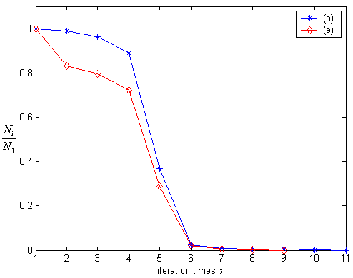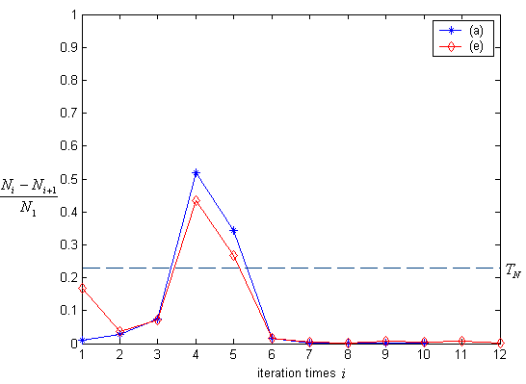
(a) (b)
Figure 3. Curves of $N_{i}/N_{1}$and $(N_{i}−N_{i+1})/{N_{1}}$ of Figure 2(a) and (e)
Meanwhile, the proposed linewidth assessment method is robust to noise, as we shown in Figure 2(e)-(h). In Figure 2, (e) is a noisy version of (a). We can see that most lines of (a) and (e) become one pixel wide at the same iteration and the curves of $N_{i}/N_{1}$and $(N_{i}−N_{i+1})/{N_{1}}$ of Figure 2(a) and (e) are much similar, as shown in Figure 3. The largest difference is caused by the noise which is thinned in the first several iterations. The average linewidths of primitives of Figure 2(a) and (e) computed by the proposed method are 9.79 and 9.76, respectively.
Using the proposed method, when $T_{N}=0\text{.}\text{25}$, the average linewidths of the four images in Figure 1 are 6.30, 5.78, 3.00, and 2.50, respectively. Experiments show that we can obtain more precise linewidths using this method.

4. Noise Distribution and Level Assessment
After we obtain the average linewidth, we need to assess the detail of the noise. Images (b), (c) and (d) in Figure 1 show some typical forms of noisy images. For this purpose, we describe the noise from two aspects: 1) noise distribution which is assessed by block method and 2) noise level which is assessed by signal to noise ratio.
4.1 Noise Distribution Assessment
In engineering drawings, there are mainly two kinds of distribution of noise: 1) the noise distributes evenly in the whole drawings, as shown in Figure 1(b); 2) the noise mainly distributes at surrounding of the primitives, as shown in Figure 1(c). We call them as TYPE I and TYPE II respectively. In this paper, we use block median filter to distinguish these two types of noise. We divide the document image into local blocks by the size about $\text{10}×\text{10}$pixels, as illustrated in Figure 4. Because we only need to detect noise rather than to remove noise at this stage, we use a $3×3$ median filter to detect noise in all blocks one by one. When a noisy point is removed by the median filter in a block, this block is a noisy block. Assume there are $M×N$ blocks in one image, among which $Z$ blocks are noisy. We can calculate the distribution of the noise $D_{\text{noise}}$ as follows:
$D_{\text{noise}}=\frac{Z}{M×N}$.
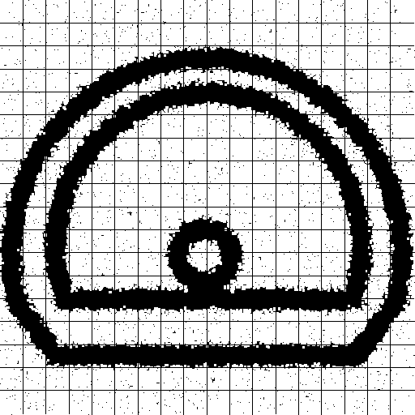
Figure 4. The block method for analysis of noise distribution
Given a pre-set threshold $T_{\text{distribution}}$, the noise type is TYPE I if $D_{\text{noise}}\text{>=}T_{\text{distribution}}$, and TYPE II otherwise. For Figure 1(b) and (c), if let $T_{\text{distribution}}=0\text{.}5$, the obtained values of $D_{\text{noise}}$ are 0.7769 and 0.4250 respectively. This means that the noise distribution of Figure 1(c) (TYPE II) is more concentrative than that of Figure 1(b) (TYPE I).
4.2 Noise Level Assessment
Next, we assess the noise level. For different noise level, we should use different de-noise method to obtain the best quality, because improper use of noise filter can reduce both noise and useful information of primitives greatly.
We use the signal to noise ratio (SNR) to describe the noise level of an image. We employ a median filter whose template size is $1\text{.}5⋅W_{\text{line}}×1\text{.}5⋅W_{\text{line}}$ to compute SNR. Such filter can reduce noise while preserving the primitives. Assume the primitives to be black and the background white. First, we count the number of all black pixels in the image and denote it as $Q$. Then the median filter is used once to wipe off noise and we count the number of the remaining black pixels again. We denote this number as $P$. $P$ is the number of primitive points and reflects the signal level. $Q−P$ is the number of noisy points that have been removed by the filter and reflects the noise level. If $Q−P=0$, it means that there is no noise in the image. When $Q−P≠0$, We define the SNR of an image as:
$\text{SNR}=\frac{P}{Q−P}$;
Usually, lower SNR means higher noise level. For instance, the SNR of Figure 1(b) and (c) are 2.399 and 1.443, respectively. It means that the noise level of (c) is higher than that of (b). However, there is another form of degradation of engineering drawings, as shown in Figure 1(d), where the primitives are too thin and discontinuous. When the median filter is applied, the primitives are also regarded as the noise and therefore wiped off from the image. As a result, its SNR is very small (only 0.285). For these different cases, different methods should be employed for noise reduction, as we will explain in the next section.
5. Adaptive Noise Reduction
Many techniques for noise reduction replace each pixel with certain function of the pixel's neighborhood. Because useful features and many noises usually have common frequency components, they are not separable in the frequency domain. Hence, linear filters tend to either amplify the noise along with useful features, or smooth out the noise and reduce useful features simultaneously.
To minimize the conflict between useful features and noise, researchers have introduced a number of adaptive noise reduction algorithms, which essentially attempt to preserve or amplify useful features while reducing noises. Median filter and morphological filters are, perhaps, the most well-known and popular filters for adaptive noise reduction. The median filter is very good at reducing some types of noise (e.g., Gaussian noise and “salt and pepper” noise), while preserving some useful features (e.g., edges). It is not so good, however, at removing dense noise, and it degrades thin lines and those features smaller than half the size of its template. The morphological filters include erosions, dilations, openings, closings, and their combinations. The action of a morphological filter depends on its structural element, which is a small pattern that defines the operational neighborhood of a pixel. The effectiveness of the median filters and morphological filters greatly relies on the size of the template and the structural element. Hence, it is very important to carefully choose them.
Based on the assessment results of primitives and noise we obtained in Section 3 and 4, we develop an adaptive noise reduction (ANR) method. We choose the median and morphological filters to reduce noise but also adjust the size of the template and the structural element adaptively according to the assessed linewidth and noise information. Let $W_{\text{line}}$, $D_{\text{noise}}$ and $\text{SNR}$denote the linewidth, noise distribution and noise level of one image, $W_{\text{ideal}}$ is a given linewidth, $T_{\text{distribution}}$ and $T_{\text{level}}$ are pre-set thresholds for $D_{\text{noise}}$ and $\text{SNR}$, $d_{\text{SE}}$ is diameter of the circle structural element. (1) If $D_{\text{noise}}\text{>=}T_{\text{distribution}}$ and $\text{SNR}\text{>=}T_{\text{level}}$, the main noise is Gaussian noise combined with some high frequency noise, we first use a median filter with a $1\text{.}5⋅W_{\text{line}}×1\text{.}5⋅W_{\text{line}}$ template to remove Gaussian noise. Then an open morphological filter with a circle structural element, $d_{\text{SE}}=0\text{.}8⋅W_{\text{line}}$, to reduce high frequency noise and smooth primitives. (2) If $D_{\text{noise}}<T_{\text{distribution}}$ and $\text{SNR}\text{>=}T_{\text{level}}$, the noise distributes surrounding the primitives concentratively and the main noise is hard pencil noise and high frequency noise combined with some Gaussian noise. Hence, we use a close morphological filter with a circle structural element, $d_{\text{SE}}=0\text{.}5⋅W_{\text{line}}$ , to remove gaps caused by hard pencil noise in primitives and an open morphological filter with a circle structural element, $d_{\text{SE}}=0\text{.}8⋅W_{\text{line}}$, to reduce high frequency noise and dense Gaussian noise and smooth primitives. (3) If $\text{SNR}<T_{\text{level}}$, it means the primitives are too thin and maybe discontinuous. In this condition, we first use a close morphological filter with a circle structural element, $d_{\text{SE}}=W_{\text{line}}$, to connect primitives, then in order to avoid losing useful information, we apply a special $3×3$ filter to remove noise, which, for a binary image, can change the value of the centre element only when the values of all other 8 neighbour elements are different from it. In this way, all single noisy points can be removed while the primitives can be preserved, even they are one pixel wide.
After removing the noise from the image, according to $W_{\text{line}}$, we use an erosion or dilation morphological filter to adjust the linewidth to the given width $W_{\text{ideal}}$, so that all de-noised images may have similar linewidth to the original noiseless images with $W_{\text{ideal}}$being their ideal linewidth. Figure 5 shows the flowchart of our ANR method.

Figure 5. The flowchart of ANR
6. Experimental Results
We have implemented a prototype system based on our proposed method. We use some noisy images of engineering drawings chosen from the Symbol Recognition Contest of GREC’03 [13] for testing. Figure 6 and Figure 7 show the experimental results of four images. In Figure 6, the top row contains the images with different types and levels of noise and the bottom row are the results of our adaptive noise reduction approach with $T_{N}=0\text{.}\text{25}$,$T_{\text{distribution}}=0\text{.}5$, $T_{\text{level}}=1\text{.}0$and $W_{\text{ideal}}=5$. Figure 7 includes curves of $N_{i}/N_{1}$ and $(N_{i−1}−N_{i})/{N_{1}}$ of the four images. We can see that there is a sharp drop on each curve, where the ordinal number of the iteration reflects the linewidth. Table 1 shows the results of $W_{\text{line}}$, $D_{\text{noise}}$ and SNR calculated by the proposed method. From the experimental results, we can see that our proposed methods can effectively reduce most noise in engineering drawings while preserving the useful features (e.g., smoothing edges of primitives and adjusting average linewidth). These noise reduction results provide us a good basis for vectorization and recognition of the contest symbols.

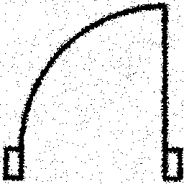 (a) | 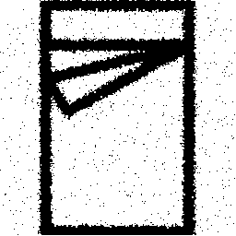  (b) | 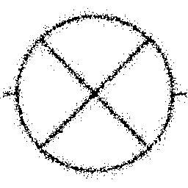  (c) | (d)
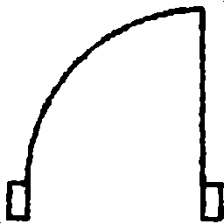 | 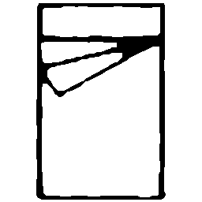 | 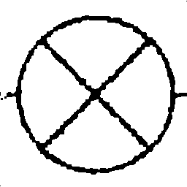 | 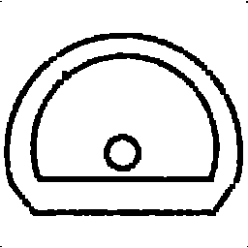
Figure 6. Comparison between original images and de-noised images
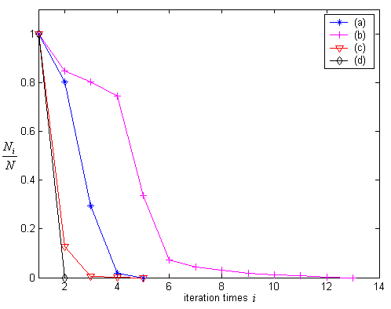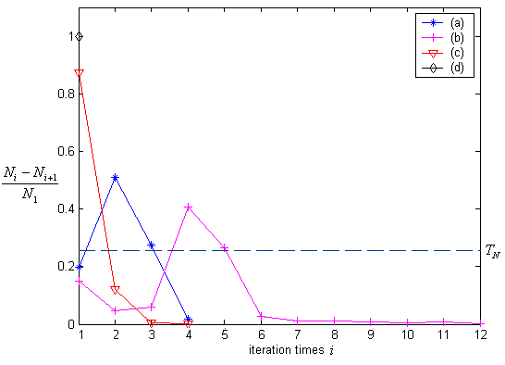
(a) (b)
Figure 7. Linewidth assesment of the top four images of Figure 6. Note that there are only two iterations for Figure 6(d), hence there is only one point for it in Figure 7(b).

Table 1. The results of noise assessment on certain images
 | $$W_{\text{line}}$$ | $$D_{\text{noise}}$$ | $$\text{SNR}$$
Figure 6(a) | 5.70 | 0.646 | 3.678
Figure 6(b) | 9.77 | 0.648 | 7.937
Figure 6(c) | 3.00 | 0.386 | 1.414
Figure 6(d) | 2.50 | 0.229 | 0.285
7. Conclusion and Future Works
In this paper, we analyzed the special features and various types and levels of noise in engineering drawings and proposed an adaptive noise reduction (ANR) method based on linewidth assessment, noise distribution assessment and noise level assessment. Compared with other noise reduction method, the proposed method can adjust the template size of median filter and structural element of morphological filter adaptively according to different types and levels of noise. The method can remove the noise while keeping the useful information of primitives. Experimental results proved effectiveness of our proposed methods.
However, some problems still need to be solved, such as how to deal with primitives with various linewidths in a single engineering drawing and how to smooth or sharp edges further while keeping much smaller features of primitives. We will continue our research on these problems and enhance the performance of our proposed adaptive noise reduction method for engineering drawings.
Acknowledgement
The work described in this paper is fully supported by a grant from the Research Grants Council of the Hong Kong Special Administrative Region, China [Project No. CityU 1073/02E].
References
- H. C. Andrews, “Monochrome Digital Image Enhancement”, Applied Optics, Vol. 15, No. 2, pp. 495-503, 1976.
- A. Lev and S. W. Zucker, and A. Rosenfeld, “Interactive Enhancement of Noisy Images”, IEEE Trans. on Systems, Man and Cybernetics, Vol. 7, No. 6, pp. 435-422, 1977.
- G. A. Mastin, “Adaptive Filters for Digital Image Noise Smoothing: An Evaluation”, Computer Vision, Graphics and Image Processing, Vol. 31, No. 1, pp. 103-121, 1985.
- J. Ishihara, M. Meguro, and N. Hamada, “Adaptive Weighted Median Filter Utilizing Impulsive Noise Detection”, Application of Digital Image Processing, Proc. SPIE 3808, pp. 406-414, 1999.
- M. Miloslavski and T. S. Choi, “Application of LUM Filter with Automatic Parameter Selection to Edge Detection”, Applications of Digital Image Processing, Proc. SPIE 3460, pp. 865-871, 1998.
- H. Oktem, K. Egizarian, and V. Katkvnik, “Adaptive De-noising of Images by Locally Switching Wavelet Transforms”, ICIP, 1999.
- F. Russo and G. Ramponi, “A Fuzzy Filter for Images Corrupted by Impulse Noise”, IEEE Signal Processing Letters, Vol. 3, No. 6, pp. 168-170, 1996.
- H. Kong and L. Guan, “A Neural Network Adaptive Filter for the Removal of Impulse Noise in Digital Images”, Neural Network, Vol. 9, No. 3, pp. 373-378, 1996.
- T. Pavlidis, “Recognition of Printed Text Under Realistic Conditions”, Pattern Recognition Letters, Vol. 14, No. 4, pp. 317-226, 1993
- T. Kanungo, R. M. Haralick, and I. Phillips, “Global and Local Document Degradation Models”, Proc. ICDAR, pp. 730-734, 1993
- Z. Jian, L. Wenyin, D. Dori, and L. Qing, “A Line Drawings Degradation Model for Performance Characterization”, Proc. ICDAR, pp. 1020-1024, 2003.
- J. C. Mott-Smith, “Medial Axis Transforms”, Picture Processing and Psychopictoris, Academic Press, New York, 1970.
- http://www.cvc.uab.es/grec2003/SymRecContest/images.htm, GREC2003 Symbol Recognition Contest.

